**1. If I find Covariance between same variable what will be the output? What will be**

**correlation coefficient?**

**Solution # 1:**

 The covariance for two random variates Xand Y, each with sample size N, is defined by the expectation value

|  |  |  |  |
| --- | --- | --- | --- |
| cov(X,Y) | = | <(X-mu_X)(Y-mu_Y)> |  |
| http://mathworld.wolfram.com/images/equations/Covariance/Inline7.gif | = | <XY>-mu_Xmu_y |  |

where mu_x=<X> and mu_y=<Y> are the respective means, which can be written out explicitly as

 cov(X,Y)=sum_(i=1)^N((x_i-x^_)(y_i-y^_))/N. 

In the special case of Y=X,

|  |  |  |  |
| --- | --- | --- | --- |
| cov(X,X) | = | <X^2>-<X>^2 |  |
| http://mathworld.wolfram.com/images/equations/Covariance/Inline22.gif | = | sigma_X^2, |  |

so the covariance reduces to the usual variance sigma_X^2=var(X).

The correlation coefficient will become equal to 1.

cor(X,Y)=cov(X,Y) / sd(X)sd(Y)

In the special case of Y=X, cor(X,X) = 1

**2. Assume I have a set of numbers. The mean, median and mode of the set of numbers are**

**equal. If I draw a Frequency plot of individual distinct numbers, how would the plot look**

**like?**

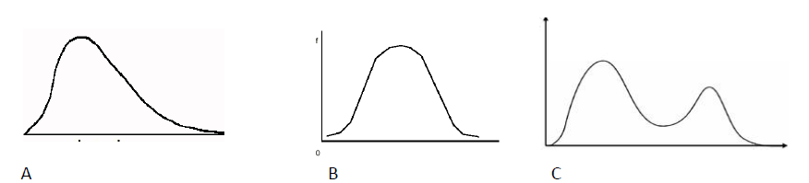

**Solution # 2:**

A distribution is said to be skewed when the mean and the median fall at different points in the distribution, and the balance of the curve ( or C.G. / center of gravity) is shifted to one side or to the other.

If the value of mean, median and mode are identical / same, it will a symmetrical distribution with bell-shaped & no skewness.

So, the correct plot will be **option B**